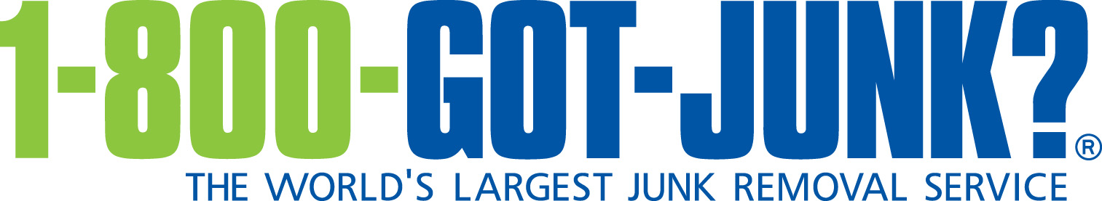

Texting ban for commercial truck drivers
A Summary of DOT and FMCSA Regulations

Provided by: Liberty Insurance Agency

In order to combat the growing number of fatalities caused by distracted driving, the Department of Transportation (DOT) and the Federal Motor Carrier Safety Administration (FMCSA) enacted a federal rule banning commercial motor vehicle operators from texting while driving. The rule was enacted in September 2010 and became effective on Oct. 27, 2010.

What is a Commercial Motor Vehicle?
The federal texting ban applies to drivers of commercial motor vehicles (CMVs). For purposes of the texting ban, a CMV is defined as a self-propelled or towed vehicle used on highways to transport persons or property in interstate commerce that either:
- Has a gross vehicle weight/gross vehicle weight rating of more than 10,000 pounds;
- Is designed or used to transport more than eight passengers (including the driver) for compensation;
- Is designed or used to transport more than 15 passengers (including the driver), not for compensation; or
- Is transporting any quantity of hazardous materials requiring placards to be displayed on the vehicle.
The ban does not apply to employees of federal, state or local governments. However, it does apply to certain drivers that are usually exempt from the Federal Motor Carrier Safety Regulations (FMCSRs), such as:
- School bus drivers who are employed by non-government entities and who transport school children and/or staff between home and school in interstate commerce; and
- Drivers of small passenger-carrying vehicles designed to transport nine to 15 passengers that are not receiving direct compensation.

Prohibition on Texting
Under the final rule, CMV drivers may not text while driving. In addition, motor carriers may not allow or require their drivers to text while driving. There is an exception for texting when necessary to communicate with law enforcement officials or other emergency services.
For purposes of this rule, driving means operating a CMV with the motor running, including while stopped as a result of traffic, a traffic control device or other momentary delays. Driving does not include CMV operation, with or without the motor running, when the driver has moved the vehicle off of the road or to the side of the road to a place where the vehicle can safely remain stationary.
Texting means manually entering alphanumeric text into, or reading text from, an electronic device. This action includes, but is not limited to, short message service, emailing, instant messaging, a command or request to access a World Wide Web page, pressing more than a single button to initiate or terminate a voice communication using a mobile telephone or engaging in any other form of electronic text retrieval or entry, for present or future communication.

Texting does not include:
- Inputting, selecting or reading information on a global positioning system or navigation system; or
- Pressing a single button to initiate or terminate a voice communication using a mobile telephone or using a device capable of performing multiple functions (for example: fleet management systems, dispatching devices, smart phones, citizens band radios, music players, etc.) for a purpose that is not otherwise prohibited by the rule.

Penalties and Enforcement
Drivers can be fined up to $2,750 for violations of the texting ban. Employers are subject to penalties of up to $11,000.
Drivers who are convicted of two or more violations of the texting ban can be disqualified from operating a CMV in interstate commerce. A driver is disqualified for 60 days if he or she is convicted of two violations in separate incidents during a three-year period. A driver is disqualified for 120 days if he or she is convicted of three or more violations in separate incidents during a three-year period.

State and Local Regulation
In addition to the texting ban, motor carriers and drivers that are subject to FMCSA regulations must also comply with the laws, ordinances and regulations of the jurisdiction in which they operate a CMV. If the federal rules are stricter than local laws, the federal rule must be obeyed.
In addition, a violation of state or local laws may also be seen as a violation of the federal regulation in states and localities that have laws related to texting while driving, non-texting cell phone use or any other similar traffic offenses.

Commercial Driver’s License
The rule also adds a federal disqualification standard for those operating with a commercial driver’s license (CDL). If a driver is convicted of a state or local law prohibiting texting while driving a CMV that requires a CDL, the driver must be disqualified by the state that issued the CDL even if that state has not have banned texting while driving. The driver must be disqualified for 60 days for two convictions within a three-year period and for 120 days for three or more convictions within three years.
States that issue CDLs were required to adopt and implement the CDL disqualification provisions before Oct. 27, 2013. States that receive Motor Carrier Safety Assistance program (MCSAP) grant funds were also required to adopt regulations on texting that are compatible with the federal rule by that date.

